Aurora's Higher Education and Research Academy
Uppal, Hyderabad, Telangana, +91 9100123456, aurora.edu.in
DEPARTMENT OF COMPUTER SCIENCE AND ENGINEERING - ARTIFICIAL INTELLIGENCE AND MACHINE LEARNING
COMPREHENSIVE PROJECT REPORT

NATURAL LANGUAGE PROCESSING

PROJECT TITLE
REAL-TIME FAKE JOB OFFER DETECTION USING NATURAL LANGUAGE PROCESSING AND BROWSER EXTENSION INTEGRATION
LEARNING GROUP NO: 5
INTERNAL GUIDE: Ms. Jaya Sri, Dept. of CSE
NAME: Polla Vishnu Vardhan
ROLL NO: 231U1R2002
Mob num: 8523851643
Email id: Vishnuvardhan.polla@aurora.edu.in

NAME: Vivek Goud Adula
ROLL NO: 231U1R2015
Mob num: 9381118626
Email id: vivekgoud.adula@aurora.edu.in

NAME: Myadarapu Navya
ROLL NO: 231U1R2024
Mob num: 9010706918
Email id: myadarapu.navya@aurora.edu.in
Aurora's Higher Education and Research Academy
Uppal, Hyderabad, Telangana, +91 9100123456, aurora.edu.in

DEPARTMENT OF COMPUTER SCIENCE AND ENGINEERING - ARTIFICIAL INTELLIGENCE AND MACHINE LEARNING

DECLARATION BY THE CANDIDATE

I, Vivek Goud Adula bearing Registration Number 231U1R2015, hereby declare that the project report entitled “Real-time fake job offer detection using Natural Language Processing and Browser Extension Integration” under the guidance of Ms. Jaya Sri, Department of Computer Science and Engineering, Aurora’s Higher Education and Research Academy, Uppal is submitted in partial fulfillment of the requirements for the award of the degree of B. Tech in Computer Science and Engineering – Artificial Intelligence and Machine Learning.

This is a record of Bonafide work carried out by me and the results embodied in this project have not been reproduced or copied from any source. The results embodied in this project report have not been submitted to any other university or institute for the award of any other degree or diploma.
Name: Vivek Goud Adula
Reg. No.: 231U1R2015
Aurora's Higher Education and
Research Academy
Uppal, Hyderabad
Aurora's Higher Education and Research Academy
Uppal, Hyderabad, Telangana, +91 9100123456, aurora.edu.in

CERTIFICATE

This is to certify that the Comprehensive Project report entitled “Real-time fake job offer detection using Natural Language Processing and Browser Extension Integration” submitted by Mr. Vivek Goud Adula bearing Registration Number 231U1R2015 for the fulfillment of the successful completion of Natural Language Processing Course in III Year III Term of B. Tech Program at Aurora’s Higher Education and Research Academy, is an authentic compilation of his efforts, completed under our guidance. We also commend their dedication and effort.

Internal Examiner Head of the Department External Examiner

ACKNOWLEDGMENT

I am very pleased to present this major Project report. This period of my student life has been truly rewarding several people were of immense help to me during my research and the preparation of my Comprehensive project report.
First, I wish to thank God Almighty who created the heavens and earth and helped me in completing this project.
I thank my parents who encouraged me to continue my Undergraduate studies, to my father and mother.
I would like to thank Mrs. Jaya Sri, Aurora’s Higher Education and Research Academy, Uppal, my project internal guide, for her guidance and help. Her insight during the course of my research and regular guidance were valuable to me.
I would also thank Dr. Chandrashekar, Registrar of our University, for extending his help.
I would also thank Dr. Mahesh Sunkari, Dean School of Engineering of our University, for extending his help.

ABSTRACT

The increasing dependence on digital platforms for job searching has led to a significant rise in recruitment-related fraud. Fake job offers distributed through email services, professional networking platforms, and online job portals often deceive job seekers by demanding registration fees, processing charges, or sensitive personal information. Many users, particularly fresh graduates and unemployed youth, struggle to distinguish between legitimate opportunities and fraudulent recruitment messages due to the realistic language used by scammers.
To address this issue, this project proposes a real-time fake job detection system based on Natural Language Processing integrated within a browser extension environment. The system automatically analyzes job-related textual content from platforms such as Gmail, LinkedIn, and jobs portals, and predicts the likelihood of fraudulent intent using machine learning-based text classification techniques.
Text preprocessing techniques including tokenization, text normalization, stop-word removal, and vectorization are applied to prepare the data for modeling. A baseline classifier using traditional machine learning algorithms such as Logistic Regression or SVM is developed for comparison, followed by a transformer-based model for improved contextual understanding.
The proposed solution provides a practical, deployable, and real-time fraud detection framework that enhances online safety for job seekers by identifying deceptive recruitment messages before users take financial or personal risks.
Keywords: Fake Job Detection, Recruitment Scam, Natural Language Processing, Text Classification, Machine Learning, BERT, Browser Extension, Real-Time Detection, Fraud Prevention

LIST OF TABLES

S.NO. | NAME OF THE TABLE | PAGE NO.
1. | Literature survey on current Objectives | 7

INDEX

SNO. | CONTENT | PAGE NUMBER
1 | Introduction | 1
1.1 | Background Knowledge | 1
1.2 | Motivation for the project | 1
1.3 | Existing System | 2
1.4 | Problem Statement | 2
1.5 | Objectives of the proposed Model | 3
1.6 | Limitations | 3
2 | Literature Survey | 5
2.1 | State of art of the proposed model | 5
2.2 | Literature survey on current objectives | 6
2.3 | Compare the existing approach | 8
2.4 | Trust or research gap | 8
3 | Project Requirement | 10
3.1 | Software requirements | 10
3.2 | Hardware Requirements | 10
3.3 | Functional requirements | 10
3.4 | Non-functional requirements | 11
4 | Project Design | 14
4.1 | Architecture Diagram | 14
4.2 | E-R Diagram | 14
5 | Methodology | 15
6 | Coding | 16
7 | Testing and results | 20
7.1 | Sample inputs and outputs | 20
7.2 | Discussion on results | 21
8 | Creativity and Innovation | 22
9 | Community Impact | 23
10 | References | 24

1. INTRODUCTION
1.1 BACKGROUND KNOWLEDGE
The rapid growth of online recruitment platforms has transformed the way job seekers search for employment opportunities. Websites, professional networking platforms, and email-based recruitment systems allow organizations to reach a large number of candidates quickly and efficiently. However, this digital transformation has also led to a significant rise in fraudulent job postings and recruitment scams that target unsuspecting job seekers.
Fake job advertisements often appear legitimate and are designed to deceive users into providing personal information or paying registration fees, processing charges, or other upfront payments. These scams not only cause financial losses but also compromise sensitive personal data. Detecting such fraudulent job postings manually can be difficult because scam messages often mimic genuine recruitment language and appear on trusted job portals or communication channels.
Traditional approaches for identifying fake job postings rely on manual verification or rule-based filtering techniques. However, these methods struggle to effectively detect sophisticated scams due to the large volume of job postings and the complexity of textual information involved. Moreover, simple keyword-based detection systems often fail to capture contextual patterns present in fraudulent job descriptions.
With the advancement of Artificial Intelligence, Natural Language Processing (NLP) has become a powerful approach for analyzing textual data and identifying hidden patterns in language. Machine learning models can automatically process job descriptions, extract meaningful features, and classify job postings as legitimate or fraudulent based on linguistic patterns and contextual information.
In this project, an AI-based fake job detection system called JobShield is developed to automatically identify fraudulent job postings using NLP and machine learning techniques. The system applies text preprocessing methods such as tokenization, stopword removal, and normalization, followed by feature extraction using TF-IDF vectorization and bi-gram analysis. A Random Forest classifier is trained on a labeled job postings dataset to accurately distinguish between legitimate and fraudulent job advertisements.
To make the solution practical and user-friendly, the trained model is integrated with a browser extension and a Flask-based API, enabling real-time analysis of job listings directly from web pages. The system scans job descriptions, evaluates scam probability, and alerts users with risk indicators such as safe, suspicious, or high-risk job postings. By combining NLP techniques with real-time browser integration, this project demonstrates how AI can enhance online safety, protect job seekers from recruitment scams, and contribute to more secure digital job search environments.

1.2 MOTIVATION FOR THE PROJECT
The motivation behind the project lies in:
- Enhancing Online Safety for Job Seekers: The increasing number of fraudulent job postings on recruitment platforms has made job searching risky for many individuals. Developing an AI-based system that can automatically detect suspicious job advertisements can help protect users from financial scams and misuse of personal information.
- Leveraging the Power of Natural Language Processing: Modern NLP techniques enable computers to analyze and understand textual data at scale. By applying text preprocessing, feature extraction, and machine learning models, it becomes possible to identify linguistic patterns commonly used in fraudulent job postings.
- Facilitating Learning and Skill Development: This project provides a practical opportunity to explore important concepts in Natural Language Processing, machine learning, and real-world system deployment. It helps learners understand text preprocessing, feature engineering using TF-IDF, classification models, and the integration of AI systems with web-based applications.
- Developing Real-Time AI Applications: Most research models focus only on offline analysis using datasets. This project aims to bridge the gap between research and real-world usage by integrating the trained NLP model with a browser extension and a Flask API, enabling real-time detection of fake job postings directly on web pages.

1.3 EXISTING SYSTEM
- Traditional methods for identifying fraudulent job postings rely heavily on manual verification by job seekers or platform moderators. This process is time-consuming, inconsistent, and often ineffective because fraudulent job advertisements are designed to closely resemble legitimate recruitment messages.
- Conventional approaches for detecting fake job postings often use rule-based filtering systems or keyword matching techniques. These methods depend on predefined patterns or blacklisted keywords, which makes them ineffective in identifying sophisticated scams that use varied language and contextual manipulation.
- Many existing research models rely on static datasets and offline analysis, where machine learning algorithms are trained and evaluated only within controlled environments. Such systems are rarely integrated into real-world applications, limiting their practical usefulness for everyday users
- Several studies focus on single-model machine learning approaches, such as Logistic Regression, Naïve Bayes, or basic classifiers. While these models provide reasonable performance, they often struggle to capture complex linguistic patterns present in fraudulent job descriptions
- Existing systems typically lack real-time deployment mechanisms such as browser extensions or integrated web-based detection tools. As a result, job seekers cannot receive immediate warnings while browsing job listings, reducing the effectiveness of these systems in preventing recruitment scams.

1.4 PROBLEM STATEMENT
The project “Fake Job Detection Using Natural Language Processing and Machine Learning” focuses on identifying fraudulent job postings by automatically analyzing textual content from online recruitment platforms. With the rapid growth of digital job portals, social media recruitment, and email-based hiring, there has been a significant increase in employment scams targeting job seekers. Fraudulent job advertisements often mimic legitimate postings and may request registration fees, personal information, or other payments, making them difficult for users to identify manually.
Traditional methods of detecting fake job postings rely on manual verification or simple rule-based filtering systems. These approaches are inefficient when dealing with large volumes of job advertisements and often fail to capture the complex linguistic patterns used in sophisticated scam messages. Conventional machine learning approaches that rely only on basic keyword matching also struggle to identify contextual relationships within textual data, resulting in inconsistent detection performance.
This project aims to address these limitations by implementing an AI-based detection system using Natural Language Processing (NLP) techniques. The system performs text preprocessing, feature extraction using TF-IDF vectorization and bi-gram analysis, and classification using a Random Forest machine learning model trained on labeled job posting datasets. These techniques enable the system to identify suspicious language patterns commonly associated with fraudulent job advertisements.
The goal of the project is to develop a reliable, accurate, and scalable fake job detection system that can assist job seekers in identifying potential recruitment scams. By integrating the trained model with a Flask-based API and a browser extension, the system enables real-time analysis of job listings directly on web pages. This approach helps improve online safety, prevent financial fraud, and provide users with instant alerts about suspicious job postings.

  - OBJECTIVES OF THE PROPOSED MODEL
The primary objective of this project is to build a complete Natural Language Processing–based system capable of identifying fraudulent job postings from online recruitment platforms. The system begins by importing the required Python libraries, loading the job posting dataset, and performing initial data exploration to understand dataset structure, text fields, and class distribution between legitimate and fraudulent job advertisements. The project also aims to implement a robust text preprocessing pipeline, including tokenization, lowercasing, removal of special characters, stopword removal, and noise filtering, ensuring that job descriptions are prepared consistently for downstream machine learning tasks.
Another key objective is to extract meaningful textual features from job descriptions using TF-IDF vectorization and bi-gram analysis. These feature extraction techniques help transform raw textual content into structured numerical representations that can capture patterns commonly found in fraudulent job advertisements. A Random Forest machine learning model is then trained on the processed dataset to classify job postings as legitimate or fraudulent. The project also involves experimenting with parameters such as feature size, model configuration, and dataset balancing techniques to improve classification accuracy and detection reliability.
The system further aims to generate predictions on unseen job listings, ensuring that the trained model can effectively identify suspicious language patterns in real-world recruitment content. Model performance is evaluated using standard machine learning metrics such as accuracy, precision, recall, F1-score, and confusion matrix analysis to provide a comprehensive understanding of the model's effectiveness in detecting fake job postings.
In addition, the project focuses on integrating the trained NLP model into a Flask-based API and a browser extension interface, enabling real-time detection of fraudulent job advertisements while users browse job portals or recruitment platforms. The final objective is to create a scalable, efficient, and user-friendly AI system that enhances online safety for job seekers by automatically identifying suspicious job listings and providing instant risk alerts.

1.6 LIMITATIONS
- The current system relies on a specific labeled dataset of job postings, and the model’s performance may decrease when encountering job advertisements written in formats or styles significantly different from the training data.
- With limited labeled examples of fraudulent job postings compared to legitimate ones, the dataset may be imbalanced, which can affect model generalization despite the use of balancing techniques during training.
- The detection model primarily analyzes textual content of job descriptions, which means scams that rely on external communication channels or hidden links may not always be fully detected.
- Natural Language Processing models may struggle to identify highly sophisticated scam messages that mimic legitimate corporate language or avoid commonly known scam keywords.
- The current implementation focuses mainly on English-language job postings, which limits the system’s ability to detect fraudulent job advertisements written in other languages.
- The system depends on accurate extraction of webpage text by the browser extension. If job listings contain complex layouts, embedded scripts, or dynamically loaded content, the extracted text may be incomplete or noisy.
- Although the Random Forest classifier performs efficiently, it may not capture deep contextual relationships in text as effectively as advanced transformer-based models such as BERT, which could improve detection accuracy in future implementations.
2. LITERATURE SURVEY
2.1 STATE OF ART OF THE PROPOSED MODEL
The proposed model for Fake Job Detection Using Natural Language Processing and Machine Learning integrates modern text analysis techniques with intelligent classification algorithms to accurately identify fraudulent job postings. Traditional approaches for detecting recruitment scams often rely on manual verification, keyword-based filtering, or rule-based detection systems. These conventional techniques struggle to handle the large volume of job advertisements available on online platforms and often fail to capture contextual linguistic patterns present in sophisticated scam messages.
In contrast, the proposed system leverages Natural Language Processing (NLP) techniques combined with machine learning models to analyze job descriptions and detect fraudulent patterns automatically. The system uses text preprocessing methods such as tokenization, stopword removal, normalization, and noise filtering to prepare job posting content for analysis. These preprocessing steps help standardize textual data and remove irrelevant information that may affect model performance.
A key component of the proposed system is TF-IDF (Term Frequency–Inverse Document Frequency) vectorization combined with bi-gram feature extraction, which transforms textual job descriptions into structured numerical representations. These features allow the system to capture important linguistic patterns such as suspicious phrases frequently used in scam job postings, including requests for registration fees or unusual recruitment processes.
The classification stage of the system employs a Random Forest machine learning model, which is known for its robustness and ability to handle high-dimensional feature spaces. Random Forest classifiers combine multiple decision trees to improve prediction accuracy and reduce overfitting, making them well-suited for text classification tasks involving complex language patterns.
To make the system practical and accessible for real-world use, the trained model is integrated into a Flask-based API and a browser extension interface. This architecture allows job listings to be scanned directly from webpages in real time. The browser extension extracts job-related text, sends it to the backend API for processing, and receives a prediction indicating the probability of the job posting being fraudulent.
Modern Python libraries such as Scikit-learn, Pandas, NumPy, and NLTK support efficient data processing, model training, and evaluation within the system. These tools enable the development of a scalable NLP pipeline capable of analyzing large volumes of job postings and generating reliable predictions.
Overall, the proposed model represents a state-of-the-art approach to recruitment scam detection, combining advanced NLP techniques with machine learning classification and real-time browser integration. This system provides an effective solution for protecting job seekers from fraudulent job advertisements while demonstrating the practical application of artificial intelligence in enhancing online safety.

2.2 LITERATURE SURVEY ON CURRENT OBJECTIVES
AUTHORS OF THE PAPER | OBJECTIVE | METHODOLOGY | PERFORMANCE / KEY OUTCOMES
Aashir Amaar et al. (2022) [1] | To detect fraudulent job advertisements using machine learning and NLP techniques while addressing class imbalance in the dataset. | Utilized the Kaggle fake job postings dataset. Applied text preprocessing including tokenization, stemming, punctuation removal, and normalization. Extracted features using Bag-of-Words (BoW) and TF-IDF. Addressed dataset imbalance using ADASYN oversampling. Implemented six supervised classifiers: Logistic Regression, Random Forest, KNN, SVM, Extra Trees, and MLP. Performance evaluated using Accuracy, Precision, Recall, and F1-score. | Extra Trees Classifier with TF-IDF and ADASYN achieved the highest accuracy (~99.9%). ADASYN significantly improved minority class detection. The study demonstrated that feature extraction and imbalance handling critically impact model performance.
Sokratis Vidros et al. (2017) Automatic Detection of Online Recruitment Frauds | To analyze Online Recruitment Fraud (ORF) and provide the first publicly available dataset for employment scam detection. | Introduced the Employment Scam Aegean Dataset (EMSCAD) consisting of 17,880 annotated job advertisements. Applied Bag-of-Words feature representation. Used machine learning classifiers including Logistic Regression, Random Forest, Naïve Bayes, and Decision Trees. Conducted exploratory data analysis and empirical evaluation. | Logistic Regression and Random Forest showed strong performance in detecting fraudulent job ads. The study highlighted dataset imbalance challenges and emphasized that text-only classification provides limited but foundational detection capability. Introduced a benchmark dataset widely used in later research.
Dinh-Hong Vu et al. (2025) Improving Fake Job Description Detection Using Deep Learning-Based NLP Techniques | To improve fake job description detection using deep learning-based NLP techniques by leveraging word embeddings and metadata integration. | Proposed NLP2FJD framework. Utilized pre-trained Word2Vec embeddings to extract semantic features from textual data. Combined textual features with meta-information from the EMSCAD dataset. Implemented deep learning models for classification. Conducted ROC curve analysis to determine optimal classification threshold. | NLP2FJD outperformed traditional machine learning methods. Integration of word embeddings and metadata significantly improved predictive performance. Achieved higher AUC and improved discrimination between fake and real job descriptions.
Shashikant Kumar et al. (2025) The Growing Threat of Fake Job Postings: A Review of Machine Learning and NLP-Based Detection Approaches | To review and compare machine learning, deep learning, and NLP-based approaches for fake job post detection and identify research gaps. | Conducted a comparative literature survey of existing fake job detection models. Analyzed approaches including Bag-of-Words, TF-IDF, word embeddings, transformer models, ensemble classifiers, and oversampling techniques. Reviewed EMSCAD dataset usage and performance benchmarks. | Identified that transformer-based and embedding-based models generally outperform traditional ML models. Highlighted challenges such as class imbalance, dataset limitations, and need for real-time fraud detection systems. Emphasized requirement for larger and cleaner datasets.
Priya Khandagale et al. (2022) Fake Job Detection Using Machine Learning | To develop an automated machine learning-based classification system to distinguish between genuine and fraudulent job postings. | Applied supervised machine learning classification techniques. Conducted exploratory data analysis on job posting dataset. Implemented multiple classifiers and ensemble approaches to compare performance. Selected best-performing model based on accuracy evaluation. | Demonstrated that ensemble-based classifiers improved prediction accuracy compared to single classifiers. Confirmed that supervised learning models can effectively classify fake and legitimate job advertisements.

2.3 COMPARE THE EXISTING APPROACH
- Traditional fake job detection systems often rely on rule-based filtering techniques or simple keyword matching methods. These approaches detect suspicious phrases such as “registration fee” or “urgent hiring” but fail to understand the contextual meaning of job descriptions. As a result, such systems are easily bypassed by scammers who slightly modify the language used in fraudulent postings.
- Conventional machine learning approaches use feature extraction methods such as Bag-of-Words (BoW) or TF-IDF combined with classifiers like Logistic Regression, Naïve Bayes, or Support Vector Machines (SVM). While these models improve detection accuracy compared to rule-based systems, they still struggle to capture deeper contextual relationships within text and often depend heavily on feature engineering.
- Deep learning–based Natural Language Processing models represent a more advanced approach by learning semantic patterns directly from textual data. Techniques such as Word2Vec embeddings, neural networks, and transformer-based models can capture contextual meaning in job descriptions more effectively than traditional methods. However, these models require large datasets and higher computational resources, making them more complex to deploy in real-time systems.
- Hybrid approaches that combine machine learning with NLP-based feature extraction techniques offer a practical balance between performance and computational efficiency. By transforming textual job descriptions into numerical feature representations and applying ensemble classifiers such as Random Forest, these systems can achieve strong detection accuracy while remaining relatively efficient.
- Although many research models demonstrate good classification accuracy, most existing systems focus mainly on offline dataset evaluation rather than real-world deployment. They rarely provide practical tools such as browser-based detection systems that can protect users while browsing job listings online. This limitation highlights the need for solutions that combine accurate NLP models with real-time detection mechanisms integrated directly into web environments.

2.4 THRUST OR RESEARCH GAP:
Despite significant advancements in Natural Language Processing and machine learning for text classification, several challenges still remain in developing highly reliable and scalable systems for detecting fraudulent job postings. Many existing approaches demonstrate promising results when tested on benchmark datasets, yet they often struggle to maintain consistent detection performance when applied to real-world recruitment platforms where job postings vary greatly in format, language style, and complexity.
One major research gap lies in the ability to effectively detect sophisticated recruitment scams that closely mimic legitimate job advertisements. Fraudulent job postings frequently use professional language and detailed descriptions to appear credible, making it difficult for traditional keyword-based or rule-based systems to identify them accurately. Even machine learning models trained on standard textual features sometimes fail to capture deeper contextual relationships within job descriptions.
Another important challenge involves the generalization capability of detection models. Job postings differ significantly across platforms, industries, and geographic regions. Variations in writing style, terminology, and formatting can affect model performance if the training dataset does not adequately represent these diverse patterns. Current systems often rely on limited datasets, which can reduce their effectiveness when deployed in broader real-world environments.
A further research gap is the lack of real-time deployment in many existing solutions. While numerous studies focus on improving classification accuracy using advanced NLP techniques, most implementations remain confined to offline experiments. Few systems provide practical tools that allow users to detect fraudulent job postings directly while browsing job websites or reading recruitment emails.
Finally, there is a need to balance accuracy, computational efficiency, and usability in fake job detection systems. Highly complex models may achieve strong predictive performance but can be difficult to deploy in real-time environments such as browser extensions. Therefore, research must focus on developing efficient NLP pipelines that combine effective feature extraction, reliable classification models, and practical deployment mechanisms that can protect users during real-world job searches.
3. PROJECT REQUIREMENT
3.1 SOFTWARE REQUIREMENTS
- Programming Language: Python
- Machine Learning & Natural Language Processing Libraries: Scikit-learn, NLTK
- Data Processing Libraries: Pandas, NumPy
- Visualization Tools: Matplotlib, Seaborn
- Feature Engineering & Text Processing: TF-IDF Vectorizer, N-gram (Bi-grams), Stopword Removal, Text Cleaning, Tokenization
- Backend Framework: Flask – used to create a REST API for real-time scam detection
- Browser Extension Technologies: JavaScript, HTML5, CSS3 – used for building the Chrome/Edge extension interface and browser interaction
- Development Environment: Visual Studio Code – for coding, debugging, and project development

3.2 HARDWARE REQUIREMENTS
- Laptop/PC
- Internet

3.3 FUNCTIONAL REQUIREMENTS
Objective 1: To develop an NLP-based machine learning model that analyzes job-related textual content and detects fraudulent job postings by identifying suspicious language patterns and scam indicators.
• The system should allow importing job posting datasets (CSV format) containing multiple attributes such as job title, company profile, job description, requirements, and fraud labels.
• The system should validate dataset integrity by checking for missing values, duplicate entries, and inconsistent textual fields.
• The system should perform text preprocessing including:
- Converting text to lowercase
- Removing URLs and HTML remnants
- Removing special characters and punctuation
- Removing stopwords
• The system should perform tokenization to break job descriptions into meaningful word tokens.
• The system should perform feature extraction using TF-IDF vectorization to convert textual job data into numerical feature vectors.
• The system should support bi-gram feature generation to capture contextual phrases such as:
- “registration fee”
- “urgent hiring”
- “work from home”
- “WhatsApp interview”
• The system should train a Random Forest classifier to learn patterns that distinguish legitimate job postings from fraudulent ones.
• The system should address dataset imbalance by balancing training data to improve detection of fraudulent job postings.
• The system should evaluate model performance using classification metrics including:
- Accuracy
- Precision
- Recall
- F1-score
• The system should save the trained machine learning model for later use in real-time prediction.

Objective 2: To implement a real-time browser-based detection tool that scans job listings and alerts users about potential recruitment scams using the trained NLP model.
• The system should provide a browser extension interface that allows users to scan job listings directly from web pages.
• The system should extract textual content from job listing webpages including job descriptions and requirements.
• The system should send the extracted text to a backend Flask API for scam detection.
• The system should perform real-time text cleaning and preprocessing before prediction to remove webpage noise such as HTML tags and embedded URLs.
• The system should convert the extracted text into numerical features using the trained TF-IDF vectorizer.
• The system should use the trained Random Forest classifier to predict whether a job listing is legitimate or fraudulent.
• The system should compute a scam probability score representing the likelihood of a job posting being fraudulent.
• The system should classify results into risk categories such as:
- Safe Job
- Suspicious Job
- High Risk Scam
• The system should display the prediction result within the browser extension using visual indicators such as:
- Risk score percentage
- Color-coded alerts (green, yellow, red)
• The system should allow users to perform one-click scanning of job listings directly from their browser.
• The system should provide a user-friendly interface with dynamic feedback to improve awareness of recruitment scams.
• The system should support continuous scanning of job content across different job portals and email platforms.

3.4 NON-FUNCTIONAL REQUIREMENTS
Objective 1: To develop an NLP-based machine learning model that analyzes job-related textual content and detects fraudulent job postings by identifying suspicious linguistic patterns and scam indicators.
- Accuracy: The system must ensure accurate detection of fraudulent job postings by correctly preprocessing textual data, generating reliable TF-IDF feature representations, and training the Random Forest classifier using balanced datasets to reduce bias.
- Scalability: The NLP pipeline should efficiently handle large volumes of job listings and textual data, allowing the model to scale for datasets containing tens of thousands of job descriptions without significant performance degradation.
- Performance: Text preprocessing, feature extraction, and model inference should execute efficiently using optimized libraries such as Pandas, NumPy, and Scikit-learn to ensure fast prediction time.
- Reliability: The system should consistently produce the same prediction results when the same trained model, preprocessing pipeline, and input job description are used.
- Robustness: The system should gracefully handle noisy text inputs such as incomplete job descriptions, HTML fragments, URLs, or unusual formatting without causing system crashes.
- Usability: The NLP model training pipeline should be modular, clearly documented, and easy to update (e.g., replacing the Random Forest classifier with other models such as Logistic Regression or transformer-based models).
- Data Integrity: The original job posting dataset should remain unchanged during preprocessing, and all transformations should be performed on processed copies of the dataset to prevent data corruption.
Objective 2: To implement a real-time browser-based detection tool that scans job listings and alerts users about potential recruitment scams using the trained NLP model.
- Accuracy: The browser extension should accurately display scam probability and risk classification based on predictions generated by the trained machine learning model.
- Scalability: The backend Flask API should support multiple prediction requests from the browser extension and allow the system to handle continuous scanning of job listings across different websites.
- Performance: Real-time prediction should occur within a few seconds so that users receive scam alerts instantly when scanning job listings.
- Robustness: The system should handle edge cases such as extremely long job descriptions, incomplete webpage text extraction, and unexpected webpage formatting without interrupting the extension functionality.
- Usability: The browser extension should provide a simple and intuitive user interface with clear risk indicators (safe, suspicious, high risk) and an easy-to-use one-click scanning feature.
- Security: Communication between the browser extension and the backend API should securely transmit job text data without exposing sensitive user information.
- Compatibility: The extension should function correctly across major Chromium-based browsers such as Google Chrome and Microsoft Edge.

4. PROJECT DESIGN
4.1 Architecture Diagram
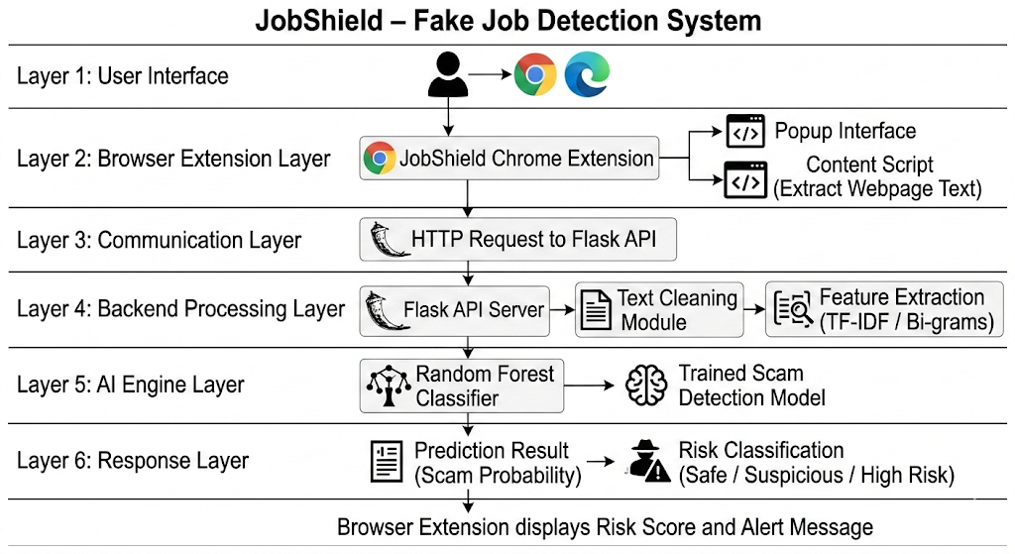
4.1 Architecture Diagram
4.2 Block Diagram
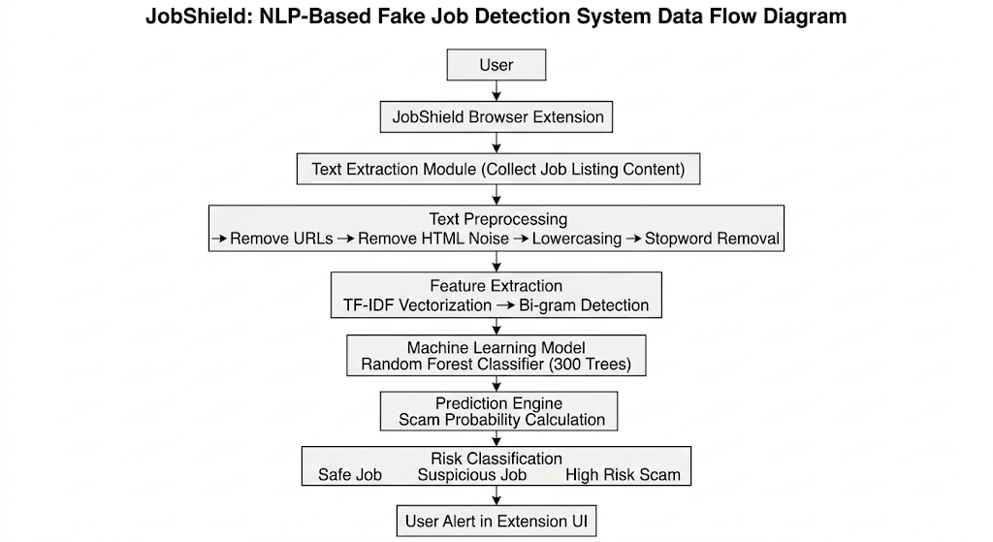
4.2 Block Diagram
4.3 Use-case Diagram
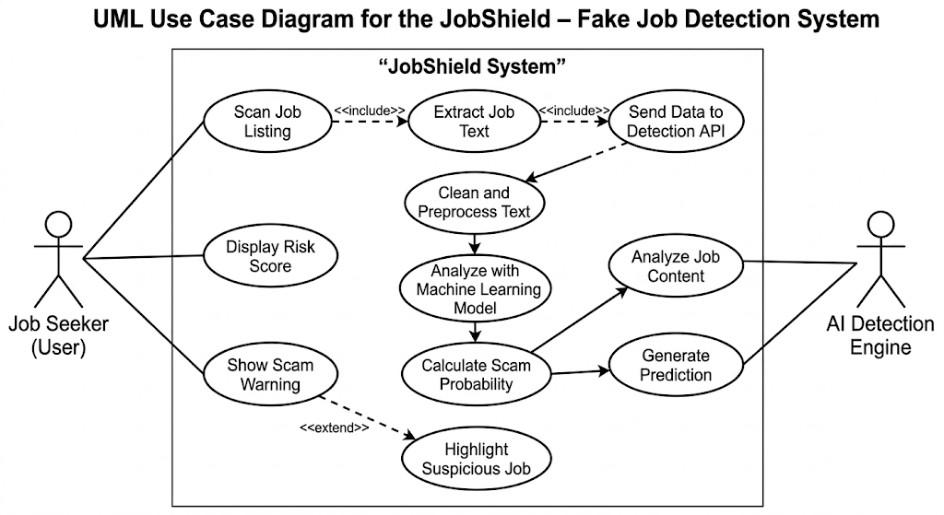
4.3 Use-case Diagram

5. METHODOLOGY
  - Job posting data is collected from publicly available datasets containing both legitimate and fraudulent job advertisements. The dataset is organized into training and testing sets, where each job posting includes fields such as job title, description, company profile, and requirements. The dataset undergoes preprocessing steps such as cleaning textual data, handling missing values, and ensuring format consistency to prepare it for machine learning analysis.
  - Text preprocessing is applied to standardize job descriptions and remove irrelevant information. This includes converting text to lowercase, removing URLs and special characters, eliminating stopwords, and performing tokenization. These preprocessing steps help transform raw textual data into a clean and structured format suitable for feature extraction.
  - Feature extraction is performed using TF-IDF (Term Frequency–Inverse Document Frequency) vectorization combined with bi-gram analysis. This technique converts textual job descriptions into numerical feature vectors while capturing important contextual phrases commonly associated with fraudulent job postings.
  - A Random Forest classifier is implemented to perform the classification task. The model learns patterns from the extracted features and predicts whether a job posting is legitimate or fraudulent. Random Forest is chosen because it combines multiple decision trees to improve prediction accuracy and reduce overfitting.
  - The model is trained using Python libraries such as Scikit-learn, Pandas, NumPy, and NLTK, and performance is evaluated using standard classification metrics including accuracy, precision, recall, F1-score, and confusion matrix. These metrics help measure how effectively the model distinguishes between genuine and fraudulent job postings.
  - To make the system practical for real-world use, the trained model is integrated with a Flask-based API and a browser extension interface. The browser extension extracts job-related text from webpages, sends it to the backend API for processing, and displays the prediction results to the user in the form of a scam probability score and risk classification.

6. CODING
app.py:
from flask import Flask, request, jsonify
import joblib
import os
import re
import nltk
from nltk.corpus import stopwords
# Ensure stopwords are available
try:
nltk.data.find("corpora/stopwords")
except LookupError:
nltk.download("stopwords")
stop_words = set(stopwords.words("english"))
BASE_DIR = os.path.dirname(os.path.abspath(__file__))
MODEL_PATH = os.path.join(BASE_DIR, "..", "model", "model.pkl")
# Load only the pipeline
if not os.path.exists(MODEL_PATH):
print(f"Error: Model not found at {MODEL_PATH}")
exit(1)
model = joblib.load(MODEL_PATH)
app = Flask(__name__)
def clean_text(text):
"""Preprocessing and language refinement"""
text = str(text).lower()
text = re.sub(r"http\S+", "", text)
text = re.sub(r"[^a-zA-Z ]", "", text)
words = text.split()
words = [w for w in words if w not in stop_words]
return " ".join(words)
@app.route("/predict", methods=["POST"])
def predict():
try:
data = request.json
raw_text = data.get("text", "")
if not raw_text or len(raw_text.strip()) < 100:
return jsonify({
"fraudulent": 0,
"scam_probability": 0.05,
"note": "Text insufficient for deep analysis."
})
# CLEAN AND PREDICT
input_text = clean_text(raw_text)
prob = model.predict_proba([input_text])[0][1]
# CALIBRATION:
# In a balanced 1:1 model, we can use a stricter threshold.
# Anything above 45% is a strong concern.
is_scam = 1 if prob > 0.45 else 0
return jsonify({
"fraudulent": int(is_scam),
"scam_probability": float(prob)
})
except Exception as e:
return jsonify({"error": str(e)}), 500
if __name__ == "__main__":
app.run(debug=True, port=5000)
preprocess.py
import re
import nltk
from nltk.corpus import stopwords
nltk.download('stopwords')
stop_words = set(stopwords.words('english'))
def clean_text(text):
text = str(text).lower()
text = re.sub(r"http\S+", "", text)
text = re.sub(r"[^a-zA-Z ]", "", text)
words = text.split()
words = [w for w in words if w not in stop_words]
return " ".join(words)
train_model.py
import pandas as pd
import joblib
import re
import os
from sklearn.model_selection import train_test_split
from sklearn.pipeline import Pipeline
from sklearn.feature_extraction.text import TfidfVectorizer
from sklearn.ensemble import RandomForestClassifier
from sklearn.metrics import classification_report
from sklearn.utils import resample
import nltk
from nltk.corpus import stopwords
# Ensure stopwords
try:
nltk.data.find("corpora/stopwords")
except LookupError:
nltk.download("stopwords")
stop_words = set(stopwords.words("english"))
# ---------- Text Cleaning ----------
def clean_text(text):
text = str(text).lower()
text = re.sub(r"http\S+", "", text)
text = re.sub(r"[^a-zA-Z ]", "", text)
words = text.split()
words = [w for w in words if w not in stop_words]
return " ".join(words)
BASE_DIR = os.path.dirname(os.path.abspath(__file__))
DATA_PATH = os.path.join(BASE_DIR, "..", "dataset", "fake_job_postings.csv")
MODEL_PATH = os.path.join(BASE_DIR, "model.pkl")
# ---------- Load Data ----------
df = pd.read_csv(DATA_PATH)
df["fraudulent"] = df["fraudulent"].map({'f': 0, 't': 1}).astype(int)
# Combine textual columns ONLY
df["combined_text"] = (
df["title"].fillna("") + " " +
df["company_profile"].fillna("") + " " +
df["description"].fillna("") + " " +
df["requirements"].fillna("")
).apply(clean_text)
# ---------- DATA BALANCING (CRITICAL) ----------
# We need to make sure the model doesn't just learn "length"
df_safe = df[df["fraudulent"] == 0]
df_fake = df[df["fraudulent"] == 1]
# Downsample safe to match fake count precisely
df_safe_balanced = resample(df_safe, replace=False, n_samples=len(df_fake), random_state=42)
df_final = pd.concat([df_safe_balanced, df_fake])
X_train, X_test, y_train, y_test = train_test_split(
df_final["combined_text"], df_final["fraudulent"], test_size=0.2, random_state=42
)
# ---------- POWER UP PIPELINE ----------
pipeline = Pipeline([
("tfidf", TfidfVectorizer(max_features=8000, ngram_range=(1,2))),
("rf", RandomForestClassifier(n_estimators=300, max_depth=50, random_state=42))
])
print("Training balanced model...")
pipeline.fit(X_train, y_train)
# EVALUATE
print(classification_report(y_test, pipeline.predict(X_test)))
# SAVE
joblib.dump(pipeline, MODEL_PATH)
print("Saved specifically balanced model.")
popup.html:
<!DOCTYPE html>
<html lang="en">

<head>
<meta charset="UTF-8">
<meta name="viewport" content="width=device-width, initial-scale=1.0">
<title>JobShield</title>
<link rel="stylesheet" href="style.css">
</head>
<body>
<div class="container">
<!-- Header -->
<div class="header">
<div class="logo-circle">
<svg width="20" height="20" viewBox="0 0 128 128" fill="none">
<path d="M64 16 L24 32 V64 C24 92 64 112 64 112 C64 112 104 92 104 64 V32 L64 16 Z" fill="white"
fill-opacity="0.9" />
</svg>
</div>
<h1>JobShield</h1>
<span class="badge">AI-Powered</span>
</div>
<p class="description">Detect fraudulent job postings instantly using our advanced AI analysis engine.</p>
<!-- Action Button -->
<button id="scan" class="scan-button">
<span id="btn-text">Analyze This Page</span>
<div id="loader" class="loading-spinner"></div>
</button>
<!-- Results Section (Hidden by default) -->
<div id="results-area" class="results-area">
<div class="status-badge" id="status-container">
<div id="st-icon"></div>
<span id="st-text">Analyzing...</span>
</div>
<div class="risk-container">
<div class="risk-label">
<span>Scam Probability</span>
<span id="risk-percentage">0%</span>
</div>
<div class="progress-bar">
<div id="progress-fill" class="progress-fill"></div>
</div>
<p id="risk-description" class="risk-text"></p>
</div>
</div>
<div class="footer">
Powered by JobShield AI Engine v2.0
</div>
</div>
<script src="popup.js"></script>
</body>
</html>
styles.css:
@import url('https://fonts.googleapis.com/css2?family=Plus+Jakarta+Sans:wght@400;500;600;700&display=swap');
:root {
--primary: #4f46e5;
--primary-dark: #4338ca;
--secondary: #0ea5e9;
--danger: #ef4444;
--success: #10b981;
--warning: #f59e0b;
--bg-gradient: linear-gradient(135deg, #0f172a 0%, #1e293b 100%);
--card-bg: rgba(255, 255, 255, 0.05);
--border-color: rgba(255, 255, 255, 0.1);
--text-main: #f8fafc;
--text-muted: #94a3b8;
}
* {
margin: 0;
padding: 0;
box-sizing: border-box;
}
body {
font-family: 'Plus Jakarta Sans', sans-serif;
width: 350px;
background: var(--bg-gradient);
color: var(--text-main);
padding: 20px;
overflow-x: hidden;
}
.container {
display: flex;
flex-direction: column;
gap: 16px;
}
.header {
display: flex;
align-items: center;
gap: 12px;
margin-bottom: 8px;
}
.logo-circle {
width: 36px;
height: 36px;
background: linear-gradient(45deg, var(--primary), var(--secondary));
border-radius: 10px;
display: flex;
align-items: center;
justify-content: center;
box-shadow: 0 4px 12px rgba(79, 70, 229, 0.3);
}
.header h1 {
font-size: 1.25rem;
font-weight: 700;
letter-spacing: -0.025em;
background: linear-gradient(to right, #fff, #94a3b8);
-webkit-background-clip: text;
-webkit-text-fill-color: transparent;
}
.badge {
padding: 2px 8px;
border-radius: 99px;
font-size: 0.65rem;
font-weight: 600;
text-transform: uppercase;
background: var(--primary);
color: white;
margin-left: auto;
}
.description {
font-size: 0.875rem;
color: var(--text-muted);
line-height: 1.5;
}
.scan-button {
position: relative;
padding: 12px;
border-radius: 12px;
border: none;
background: var(--primary);
color: white;
font-size: 0.95rem;
font-weight: 600;
cursor: pointer;
transition: all 0.2s cubic-bezier(0.4, 0, 0.2, 1);
display: flex;
align-items: center;
justify-content: center;
gap: 8px;
overflow: hidden;
box-shadow: 0 4px 12px rgba(79, 70, 229, 0.2);
}
.scan-button:hover {
background: var(--primary-dark);
transform: translateY(-1px);
box-shadow: 0 6px 16px rgba(79, 70, 229, 0.3);
}
.scan-button:active {
transform: translateY(0);
}
.loading-spinner {
width: 18px;
height: 18px;
border: 2px solid rgba(255, 255, 255, 0.3);
border-top-color: #fff;
border-radius: 50%;
animation: spin 0.8s linear infinite;
display: none;
}
@keyframes spin {
to {
transform: rotate(360deg);
}
}
.results-area {
background: var(--card-bg);
border: 1px solid var(--border-color);
border-radius: 16px;
padding: 16px;
backdrop-filter: blur(12px);
display: none;
animation: slideUp 0.3s ease-out;
}
@keyframes slideUp {
from {
opacity: 0;
transform: translateY(10px);
}
to {
opacity: 1;
transform: translateY(0);
}
}
.status-badge {
display: flex;
align-items: center;
gap: 8px;
font-weight: 600;
font-size: 1rem;
margin-bottom: 12px;
}
.status-icon {
width: 20px;
height: 20px;
}
.risk-container {
margin-top: 12px;
}
.risk-label {
display: flex;
justify-content: space-between;
font-size: 0.75rem;
color: var(--text-muted);
margin-bottom: 6px;
}
.progress-bar {
height: 6px;
background: rgba(255, 255, 255, 0.1);
border-radius: 99px;
overflow: hidden;
}
.progress-fill {
height: 100%;
width: 0%;
transition: width 1s cubic-bezier(0.4, 0, 0.2, 1);
background: var(--success);
}
.risk-text {
font-size: 0.75rem;
margin-top: 8px;
line-height: 1.4;
}
.footer {
font-size: 0.7rem;
text-align: center;
color: rgba(148, 163, 184, 0.5);
margin-top: 8px;
}
/* Status variants */
.safe {
color: var(--success);
}
.danger {
color: var(--danger);
}
.warning {
color: var(--warning);
}
popup.js:
document.getElementById("scan").addEventListener("click", async () => {
const scanBtn = document.getElementById("scan");
const loader = document.getElementById("loader");
const btnText = document.getElementById("btn-text");
const resultsArea = document.getElementById("results-area");
const progressFill = document.getElementById("progress-fill");
const riskPercentage = document.getElementById("risk-percentage");
const stText = document.getElementById("st-text");
const statusContainer = document.getElementById("status-container");
const riskDescription = document.getElementById("risk-description");
// UI Feedback: Loading state
scanBtn.disabled = true;
loader.style.display = "block";
btnText.textContent = "Analyzing...";
resultsArea.style.display = "none";
try {
let [tab] = await chrome.tabs.query({ active: true, currentWindow: true });

const results = await chrome.scripting.executeScript({
target: { tabId: tab.id },
function: getPageText
});
const pageText = results[0].result;
const response = await fetch("http://127.0.0.1:5000/predict", {
method: "POST",
headers: {
"Content-Type": "application/json"
},
body: JSON.stringify({ text: pageText })
});
if (!response.ok) throw new Error("API Offline");
const data = await response.json();
// Calculate risk
const riskProb = data.scam_probability;
const riskPercent = Math.round(riskProb * 100);
// Display results
resultsArea.style.display = "block";
progressFill.style.width = riskPercent + "%";
riskPercentage.textContent = riskPercent + "%";
if (riskProb >= 0.45) {
statusContainer.className = "status-badge danger";
stText.textContent = "🚨 High Scam Risk!";
progressFill.style.background = "#ef4444";
riskDescription.innerHTML = "This job contains <strong>very high scam markers</strong>. We strongly advise against sharing personal or payment information.";
} else if (riskProb >= 0.22) {
statusContainer.className = "status-badge warning";
stText.textContent = "⚠️ Use Professional Caution";
progressFill.style.background = "#f59e0b";
riskDescription.innerHTML = "Moderate suspicious risk. This posting may use non-standard language. Verify the recruiter through official channels.";
} else {
statusContainer.className = "status-badge safe";
stText.textContent = "✅ Verified Professional";
progressFill.style.background = "#10b981";
riskDescription.innerHTML = "Clean score. Posting appears to follow standard professional industry standards.";
}
} catch (error) {
console.error("JobShield Error:", error);
resultsArea.style.display = "block";
stText.textContent = "Error: API Connection Failed";
riskDescription.textContent = "Please ensure the JobShield server is running on your machine.";
} finally {
scanBtn.disabled = false;
loader.style.display = "none";
btnText.textContent = "Scan Again";
}
});
function getPageText() {
return document.body.innerText;
}
manifest.json:
{
"manifest_version": 3,
"name": "JobShield - Fake Job Detector",
"version": "1.0",
"description": "Detect fake job offers using NLP",
"permissions": [
"activeTab",
"scripting"
],
"host_permissions": [
"http://127.0.0.1:5000/*"
],
"icons": {
"128": "icon.png"
},
"action": {
"default_popup": "popup.html",
"default_icon": "icon.png"
}
}

7. TESTING AND RESULTS
7.1 SAMPLE INPUTS AND OUTPUTS
  - JobShield Extension

Figure 1: JobShield Browser Extension Successfully Installed
  - Job Listing Page Before Scan

Figure 2: Job Listing Webpage Before Scam Detection
  - Extension Popup Interface

Figure 3: JobShield Extension User Interface
  - Scanning the Job Listing
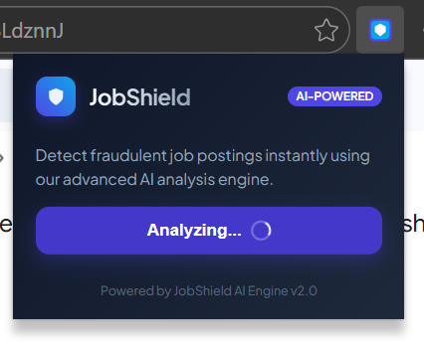
Figure 4: User Initiating Job Listing Scan
  - Fake Job Detection Output

Figure 5: Detection of Fraudulent Job Posting
  - Legitimate Job Detection Output

Figure 6: Detection of Legitimate Job Posting
  - Risk Indicator / Alert Display
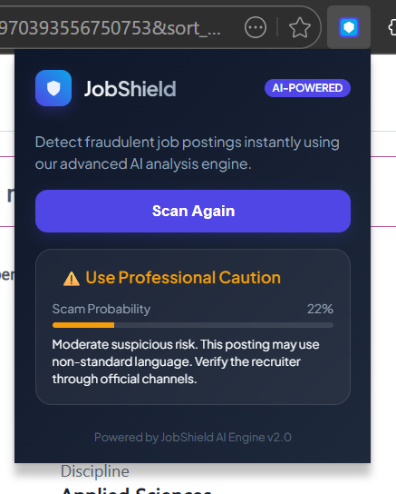
Figure 7: Risk Alert Displayed to the User

7.2 DISCUSSION
This project successfully developed and evaluated a machine learning–based Natural Language Processing system for detecting fraudulent job postings. By implementing an NLP pipeline consisting of text preprocessing, feature extraction using TF-IDF and bi-gram analysis, and classification using a Random Forest model, the system was able to analyze job descriptions and identify suspicious recruitment patterns with reliable accuracy.
Each stage of the system contributed to improving the effectiveness of fake job detection. The text preprocessing pipeline played a crucial role in cleaning and standardizing job descriptions by removing URLs, special characters, and irrelevant textual noise. Tokenization and stopword removal ensured that only meaningful textual information was retained, allowing the model to focus on important linguistic patterns associated with fraudulent job postings.
Feature extraction using TF-IDF vectorization combined with bi-gram detection enabled the model to capture important contextual phrases frequently used in scam advertisements. Expressions such as requests for registration fees, unusual hiring procedures, or urgent recruitment messages were effectively represented as numerical features, allowing the classifier to distinguish between legitimate and fraudulent job descriptions more accurately.
The Random Forest classifier served as the core machine learning model for classification. Its ensemble structure allowed multiple decision trees to analyze different subsets of textual features, improving prediction stability and reducing the risk of overfitting. Compared to simple rule-based detection systems, the model demonstrated a stronger ability to identify complex language patterns within job postings.
A key strength of the project is the integration of the trained model with a real-time detection system. By deploying the model through a Flask-based API and integrating it with a browser extension, the system enables users to analyze job listings directly while browsing recruitment platforms. The extension extracts webpage text, sends it to the backend model, and returns a scam probability score along with a risk classification such as safe, suspicious, or high risk.
The results demonstrate that Natural Language Processing combined with machine learning provides an effective solution for detecting fraudulent job advertisements. The system not only improves detection accuracy compared to traditional keyword-based approaches but also offers a practical real-time application that enhances online safety for job seekers.
Overall, the project achieved its objective of building a scalable and deployable fake job detection system. The implementation highlights how AI can be applied to real-world cybersecurity and fraud prevention challenges. The system also provides valuable insights into how machine learning models interpret textual job descriptions and detect linguistic patterns associated with recruitment scams.
Future improvements could include the integration of advanced transformer-based NLP models such as BERT, expansion of the training dataset to include more diverse job postings, and the addition of multilingual support to detect fraudulent job advertisements across different languages and platforms.

8. CREATIVITY AND INNOVATION
This project introduces a creative and practical approach to detecting fraudulent job postings by combining Natural Language Processing techniques with a real-time browser-based deployment system. Instead of developing a purely theoretical machine learning model, the project integrates text processing, machine learning classification, and browser extension technology to create a complete AI-driven solution capable of protecting users during real-world job searches.
One of the key innovative aspects of this work is the integration of an NLP-based detection model with a browser extension interface. While many research studies focus on building accurate machine learning models for detecting fraudulent job postings, very few systems provide a direct deployment mechanism that allows users to benefit from the model while browsing job listings. The JobShield system bridges this gap by enabling real-time scam detection directly within the web browser environment.
Another creative component of the project is the combination of TF-IDF feature extraction with bi-gram analysis for capturing contextual language patterns. Instead of relying only on single keywords, the system analyzes two-word phrase combinations commonly found in recruitment scams. This approach allows the model to better identify suspicious recruitment patterns such as requests for registration fees, unusual hiring procedures, or urgent job offers.
The use of a Random Forest classifier as the primary detection model further enhances the system's robustness. Random Forest models combine multiple decision trees to analyze different aspects of textual data, improving prediction reliability and reducing overfitting. This ensemble-based approach allows the system to capture complex linguistic relationships within job descriptions that simpler rule-based systems cannot effectively detect.
Another innovative element is the modular system architecture, which separates the NLP processing pipeline, machine learning model, API layer, and browser extension interface. This modular design makes the system flexible and scalable, allowing future integration of more advanced NLP models such as transformer-based architectures or the addition of new detection features.
Furthermore, the project emphasizes practical usability and real-world impact rather than focusing solely on theoretical model performance. By providing a user-friendly browser extension that automatically scans job listings and displays scam probability alerts, the system offers a direct protective tool for job seekers.
Overall, the creativity and innovation of this project lie in its combination of NLP-based fraud detection, machine learning classification, and real-time browser deployment, transforming academic research into a practical AI-powered security tool that enhances online job search safety.

9. COMMUNITY IMPACT
This project has the potential to create a meaningful impact on society by helping protect job seekers from fraudulent recruitment scams. With the rapid growth of online job portals, social media recruitment, and digital hiring platforms, employment scams have become increasingly common. Fraudulent job advertisements often target students, fresh graduates, and unemployed individuals by requesting registration fees or personal information. By developing an AI-based system capable of automatically detecting suspicious job postings, this project contributes to improving online safety and preventing financial exploitation.
One of the most important contributions of this system is its ability to provide real-time protection for job seekers while browsing job listings online. Through the integration of Natural Language Processing and a browser extension interface, the system can analyze job descriptions directly from web pages and alert users about potential scams before they apply or share personal details. This proactive detection mechanism helps users make safer decisions during their job search.
The project is particularly beneficial for individuals who may lack awareness about recruitment fraud. Many job seekers, especially students and first-time applicants, may not easily recognize suspicious job advertisements. The system acts as an intelligent assistant that highlights potential risks, increasing awareness and reducing the likelihood of falling victim to fraudulent schemes.
Another significant impact lies in the system’s ability to support the broader digital safety ecosystem. As online fraud continues to evolve, AI-driven detection systems like JobShield demonstrate how modern technologies can be used to protect users in digital environments. By combining machine learning with real-time deployment tools, the project showcases how academic research can be transformed into practical solutions for everyday problems.
The modular architecture of the system also encourages future innovation and research in AI-based fraud detection. Developers and researchers can build upon this work to expand detection capabilities, incorporate advanced NLP models, or integrate similar protection mechanisms into job portals and recruitment platforms.
Beyond direct technical contributions, the project also raises awareness about the importance of safe online job searching practices. By highlighting the risks associated with fraudulent recruitment messages and demonstrating how AI can assist in identifying them, the project promotes responsible digital behavior and strengthens public trust in AI-powered safety tools.
Overall, this project contributes to the community by enhancing online job search security, protecting individuals from financial fraud, promoting AI-based safety solutions, and encouraging the responsible use of technology to address real-world social challenges.

10. REFERENCES
- Amaar, Aashir, Wajdi Aljedaani, Furqan Rustam, Saleem Ullah, Vaibhav Rupapara, and Stephanie Ludi. "Detection of fake job postings by utilizing machine learning and natural language processing approaches." Neural Processing Letters 54, no. 3 (2022): 2219-2247.
- Vidros, Sokratis, Constantinos Kolias, Georgios Kambourakis, and Leman Akoglu. "Automatic detection of online recruitment frauds: Characteristics, methods, and a public dataset." Future Internet 9, no. 1 (2017): 6.
- Vu, Dinh-Hong, Kien Nguyen, Khai Thien Tran, Bay Vo, and Tuong Le. "Improving fake job description detection using deep learning-based NLP techniques." Journal of Information and Telecommunication 9, no. 1 (2025): 113-125.
- Kumar, Shashikant, Sadiya Yasmeen, and Prabhat Kumar. "The Growing Threat of Fake Job Postings: A Review of Machine Learning and NLP-Based Detection Approaches." Revolutionary Advances in Computing and Electronics: An International Journal (2025): 41-51.
- Khandagale, Priya, Akshata Utekar, Anushka Dhonde, and S. S. Karve. "Fake Job Detection using Machine Learning." International Journal for Research in Applied Science & Engineering Technology (IJRASET) 10, no. 5 (2022): 1826.

